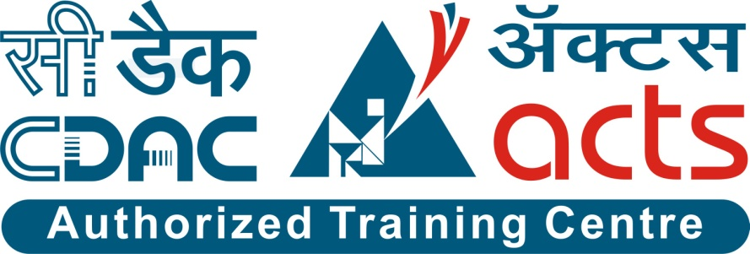

Project Name: E-RATIONING SYSTEM

Branch PG-DAC Sept- 2021.

Documentation On

**“E-RATIONING SYSTEM”**

PG-DAC Sept 2021

**Guided By: Snehal Somvanshi**

Submitted By:

**Group No: 19**

* **Amar Ingale 210943020006**
* **Varsha Ghute 210943020025**
* **Aarti Karpe 210943020035**
* **Avishkar Katkar 210943020036**

**Table of Contents**

**1. Introduction 1**

1.1 Document Purpose **1**

1.2 Project Background **1**

1.3 Aim & Objectives **1**

**2. Business Requirements Overview**…...……………………………………………………**2**

**3.Functional Requirements** **2**

3.1 Customer Module **2**

3.2 Retailer Module **3**

3.3 Government Authority Module **3**

3.4 Admin Module **3**

**4.** **Non-Functional Requirement…………….…….….….……………………………………3**

**5. Use Case Diagram 4**

5.1 Admin **4**

5.2 Customer **5**

5.3 Retailer **6**

5.4 Government Authority **7**

**6. Database Design 7**

1 Login **7**

2 Customer **8**

3 Retailer……………………………………………………………………………….……**8**

4 Product **8**

5 Order Item **9**

6 Order **9**

7 Admin Stock **9**

8 Retailer Stock **10**

9 Customer Stock **10**

**7. E-R Diagram………………………………………………………………………………………11**

**8. Snapshots 12**

**9. Conclusion 22**

**List of Figures**

**Use Case Diagrams**

Fig 1 Admin 4

Fig 2 Customer 5

Fig 3 Retailer 6

Fig 4 Government Authority…………….….………………………………………………7

Fig 4 ER Diagram…………………………………………………..……………………..11

1. **Introduction:**
   1. **Document Purpose:**

This document explains the system requirements and scope for developing E-Rationing System.

E-Rationing System could be divided into the five main parts, Customer part, Retailer part, Government authority part, Admin part and the acknowledgement part.

This document describes the system requirement of the Account part.

## Project Background:

Public Distribution System (PDS) is an Indian food security system. It is established by the Government of India under Ministry of Consumer Affairs, Food, and Public Distribution are managed jointly with state governments in India. The traditional PDS is used to distribute grocery items to India’s poor who are valid ration card holders. The validity and the allocation of the ration cards are monitored by the state governments. A ration card holder should be given food grain as per the norms of PDS. However, there are concerns about the efficiency of the distribution process. In order to make it efficient and improve the current system of PDS we are implementing e-Ration System.

## Aim & Objectives:

* The main objective of this project is to build a website which will help Customer to order available items in PDS and see the transactions.
* Through Website Government authority can register customers and retailers having valid id proof. Hence duplicate, bogus and ineligible beneficiaries can be avoided.
* Maintaining the transparency between Customer and Retailer.

1. **Business Requirements Overview:**

* E-Rationing System is a Web application for providing online ration facility to customers.
* E-Rationing System is available in India.
* There are mainly three types of users. One is the Customer, other is Retailer and the third one is government authority.
* Customer can go through available products in ration shop, place an order, view transaction history etc.
* Retailer can accept or reject the order from customer based on available stock.
* Government authority can register valid customers and retailers. He can also block the user in case of any fraudulent activity.
* E-Rationing System is maintained by Admin.

1. **Functional Requirements Overview:**

E-Rationing System consists of four modules described as below.

1. Customer Module
2. Retailer Module
3. Government Authority Module
4. Admin Module

# **3.1 Customer Module**

* Customer will get Login credentials from Government Authority
* Customer will be able to select product from product catalog.
* Customer will be able to add selected items with quantity in the cart maintained by the system.
* Customer can view transaction/order history.
* Customer is allowed to change his/her mobile number and address.

# **Retailer Module**

* E-Rationing System provides the functionality which allows Retailer to display product catalogue and price (as per gov rule)
* Retailer can update products and their stock.
* Retailer will be able to update the individual customer’s stock (Customer will get notification.)

# **Government Authority Module**

* E-Rationing System provides the functionality which allows government authority to register a new customer or a new retailer.
* Government authority can verify as well as update customer’s and retailer’s details.
* Government authority can block the account of end user in case of fraudulent activity.

# **Admin Module**

* E-Rationing System should provide all functionality to admin to handle the System.
* Admin has control and see the Customer, retailer and government authority details.
* If admin found any in-appropriate details, admin can delete those entries.
* Admin can update the rates and quantity whenever required.

1. **Non-Functional Requirement:**

* The website should use professional design, look and feel and color scheme.
* Users will have no limitations for accessing the application through Internet. The portal being an internet application, it is difficult specify exact number of visitor or users. Hence, we will target the system to support between 5 and 10 million users on launch of phase 1.
* Being a public website, the site must follow general usability guidelines for menus, navigation, colors, links and other actions provided on the screens.
* The system should be designed in such a manner that user will be able to complete tasks in minimum number of steps.
* The system should provide good throughput and response to multiple users without burdening the system by using appropriate number of servers.

## 5. Use-Case Diagram

**5.1 Admin:**

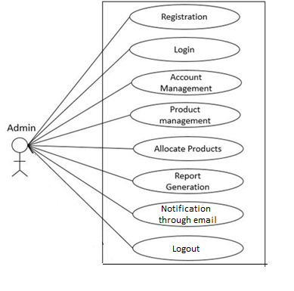

Fig. Use-Case Diagram for Admin

## 5.2 Customer:

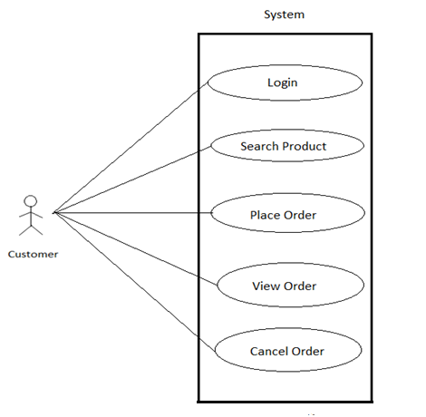

Fig. Use-Case Diagram for Customer

**5.3 Retailer:**

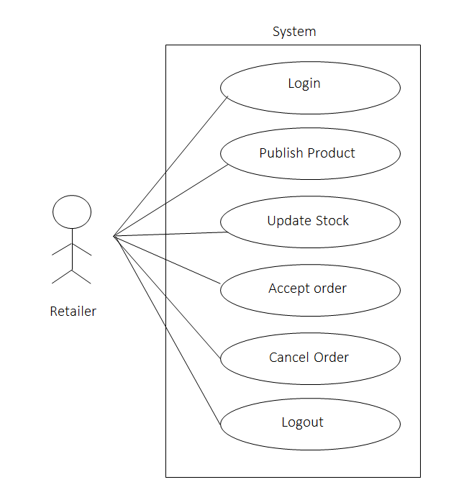

Fig. Use-Case Diagram for Retailer

**5.4 Government Authority:**

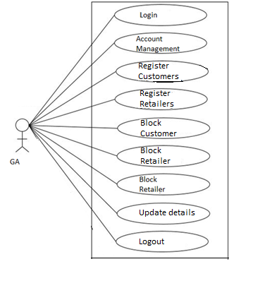

Fig. Use-Case Diagram for Government Authority

1. **Database Design:**
2. **Tbl_Login**

|  |  |  |  |  |
| --- | --- | --- | --- | --- |
| **Field** | **Type** | **Null** | **Key** | **Description** |
| Loginid | Integer | No | Primary key | Login ID |
| Username | Varchar (10) | NO |  |  |
| Password | Varchar (15) | No |  | Account Password |
| Email | Varchar (50) | No |  | Email |
| Role | Varchar (20) | No |  | Role of User (Customer/ Retailer/ GA) |

1. **Tbl_Customer**

|  |  |  |  |  |
| --- | --- | --- | --- | --- |
| **Field** | **Type** | **Null** | **Key** | **Description** |
| Cid | Integer | No | Primary key | Customer ID |
| Cname | Varchar (45) | No |  | Customer Name |
| ContactNo | Integer | No |  | Contact No. |
| Address | Varchar (100) | No |  | Permanent Address |
| Pincode | Integer | No |  | Pin code |
| Gender | Varchar (10) | No |  | Gender Information |
| AadharNo | Integer | No |  | Aadhar no |
| FamilyMembers | Integer | No |  | No. Of Dependent |
| Loginid | Integer | No | Foreign key | Reference to Tbl_Login (Loginid) |

1. **Tbl_Retailer**

|  |  |  |  |  |
| --- | --- | --- | --- | --- |
| **Field** | **Type** | **Null** | **Key** | **Description** |
| Rid | Integer | No | Primary key | Customer ID |
| Rname | Varchar (45) | No |  | Retailer Name |
| Regno | Integer | No |  | Registration no |
| Contactno | Integer | No |  | Contact No. |
| Address | Varchar (100) | No |  | Permanent Address |
| Pincode | Integer | No |  | Pin code |
| Gender | Varchar (10) | No |  | Gender Information |
| Status | Integer | No |  | Enabled / Disabled |
| Loginid | Integer | No | Foreign key | Reference to Tbl_Login (Loginid) |

1. **Tbl_Product**

|  |  |  |  |  |
| --- | --- | --- | --- | --- |
| **Field** | **Type** | **Null** | **Key** | **Description** |
| Pid | Integer | No | Primary key | Product ID |
| Pname | Varchar (45) | No |  | Product Name |
| Rate | Double | No |  | Product Price per kg |

1. **Tbl_OrderItems**

|  |  |  |  |  |
| --- | --- | --- | --- | --- |
| **Field** | **Type** | **Null** | **Key** | **Description** |
| Oiid | Integer | No | Primary key | Order Item ID |
| Productid | Integer | No | Foreign key | Reference to Tbl_Product (Pid) |
| Quantity | Integer | No |  | Product Quantity |
| Amount | Double | No |  | Amount |
| Orderid | Integer | No | Foreign key | Reference to Tbl_Order (Orderid) |

1. **Tbl_Order**

|  |  |  |  |  |
| --- | --- | --- | --- | --- |
| **Field** | **Type** | **Null** | **Key** | **Description** |
| Orderid | Integer | No | Primary key | Order id |
| Total Price | Double | No |  | Total Price |
| Order Date | DateTime | No |  | Date and time |
| OrderStatus | Varchar (50) | No |  | Placed/Pending/delivered |
| Retailerid | Integer | No | Foreign key | Reference to Tbl_Retailer (Retailerid) |
| Customerid | Integer | No | Foreign key | Reference to Tbl_Customer (Customerid) |

1. **Tbl_AdminStock**

|  |  |  |  |  |
| --- | --- | --- | --- | --- |
| **Field** | **Type** | **Null** | **Key** | **Description** |
| Asid | Integer | No | Primary key | Admin Stock ID |
| Loginid | Integer | No | Foreign key | Reference to Tbl_Login (Loginid) |
| Productid | Integer | No | Foreign key | Reference to Tbl_Product (Productid) |
| TotalQty | Double | No |  | Total Quantity |
| AvailableQty | Double | No |  | Available Quantity |
| Month | Varchar (12) | No |  | Month of Stock Allotment |
| Year | Integer | No |  | Year of Stock Allotment |

1. **Tbl_RetailerStock**

|  |  |  |  |  |
| --- | --- | --- | --- | --- |
| **Field** | **Type** | **Null** | **Key** | **Description** |
| Rsid | Integer | No | Primary key | Retailer Stock ID |
| Retailerid | Integer | No | Foreign key | Reference to Tbl_Retailer (Retailerid) |
| Productid | Integer | No | Foreign key | Reference to Tbl_Product (Productid) |
| AllocatedQty | Integer | No |  | Allocated Quantity |
| AvailableQty | Integer | No |  | Available Quantity |
| Month | Varchar (12) | No |  | Month of Stock Allotment |
| Year | Integer | No |  | Year of Stock Allotment |

1. **Tbl_CustomerStock**

|  |  |  |  |  |
| --- | --- | --- | --- | --- |
| **Field** | **Type** | **Null** | **Key** | **Description** |
| Csid | Integer | No | Primary key | Customer Stock ID |
| Customerid | Integer | No | Foreign key | Reference to Tbl_Customer (Customerid) |
| Productid | Integer | No | Foreign key | Reference to Tbl_Product (Productid) |
| AllocatedQty | Integer | No |  | Allocated Quantity |
| AvailableQty | Integer | No |  | Available Quantity |
| Month | Varchar (12) | No |  | Month of Stock Allotment |
| Year | Integer | No |  | Year of Stock Allotment |

## ER-Diagram:

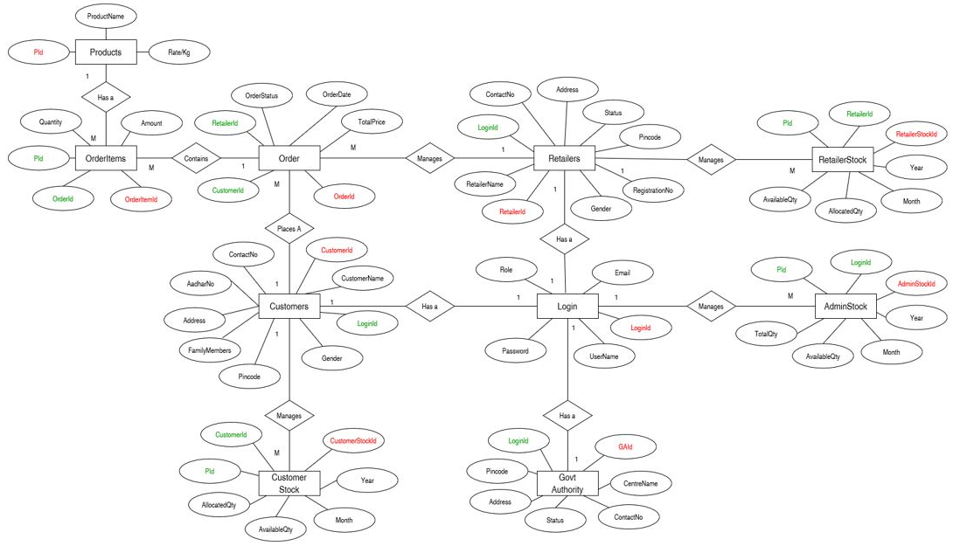

**E-R diagram shows database of E-Rationing System**

**8. Snapshots:**

**8.1 Home Page:**

Following snapshot shows the Home page for e-Rationing System

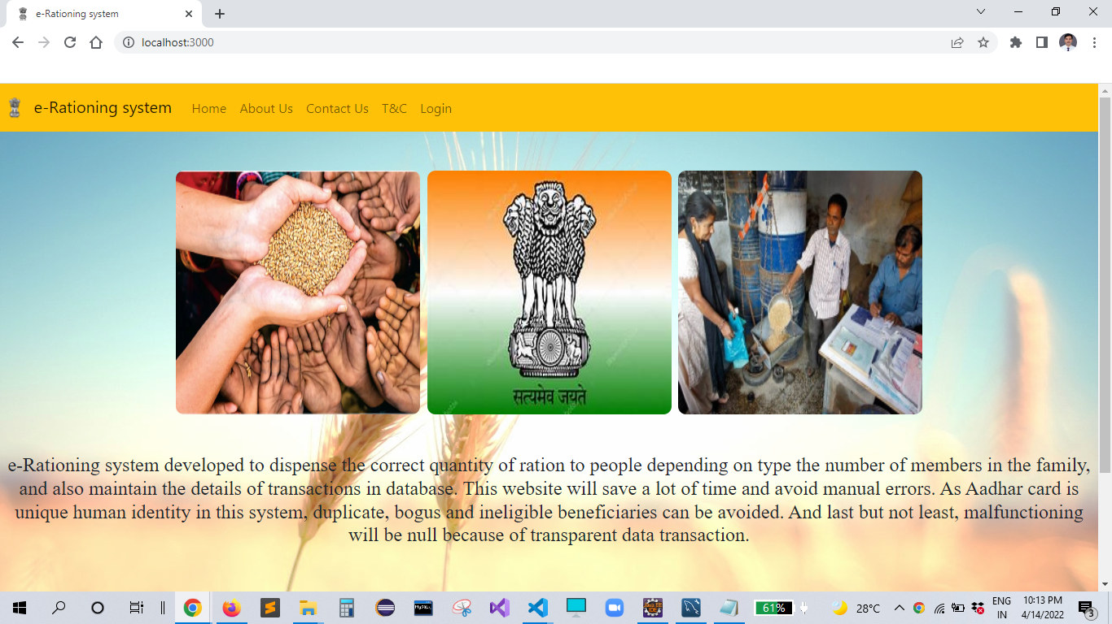

This page contains following controls

* Home
* About Us
* Contact Us
* T & C
* Login

**8.2 About us:**

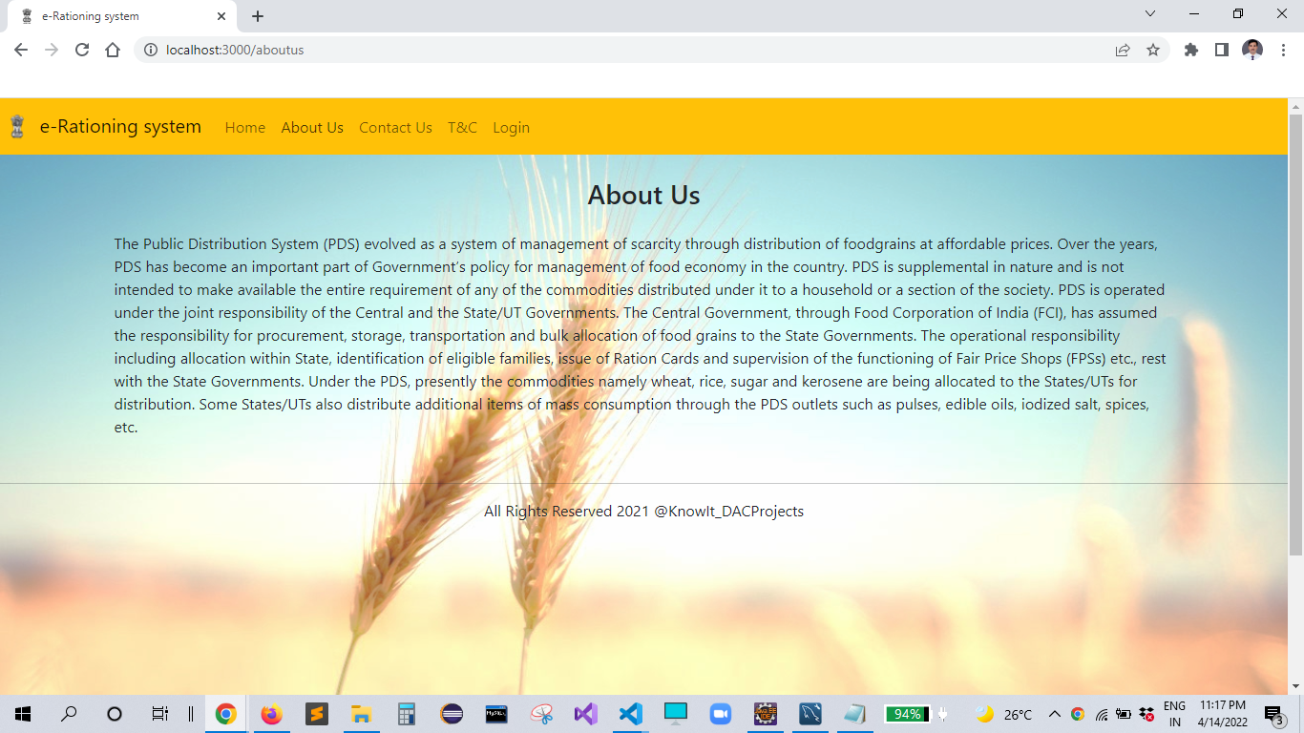

**8.3 Contact us:**

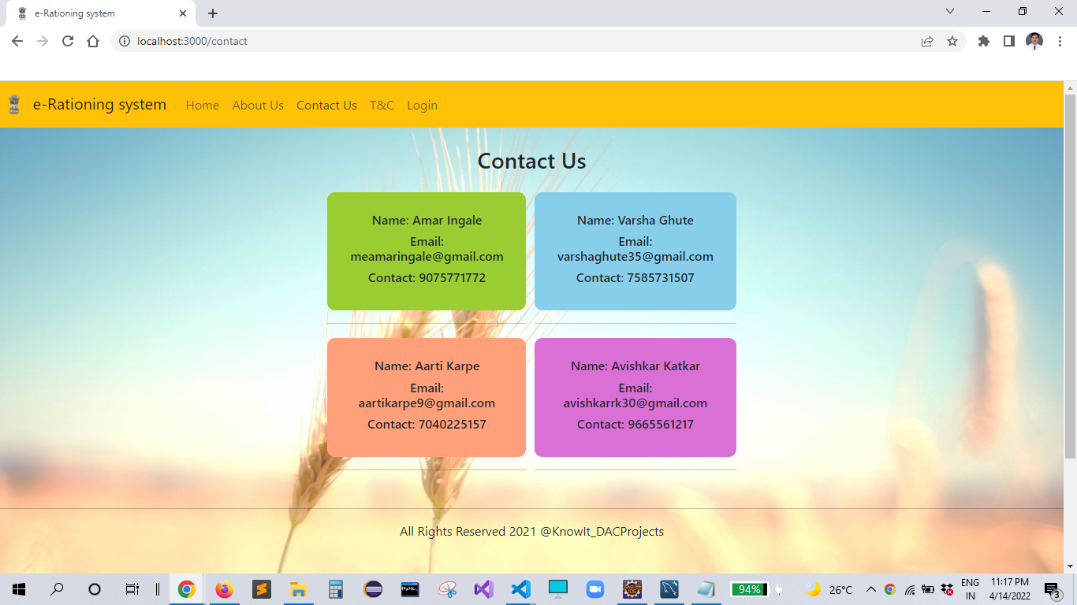

**8.4 T & C:**

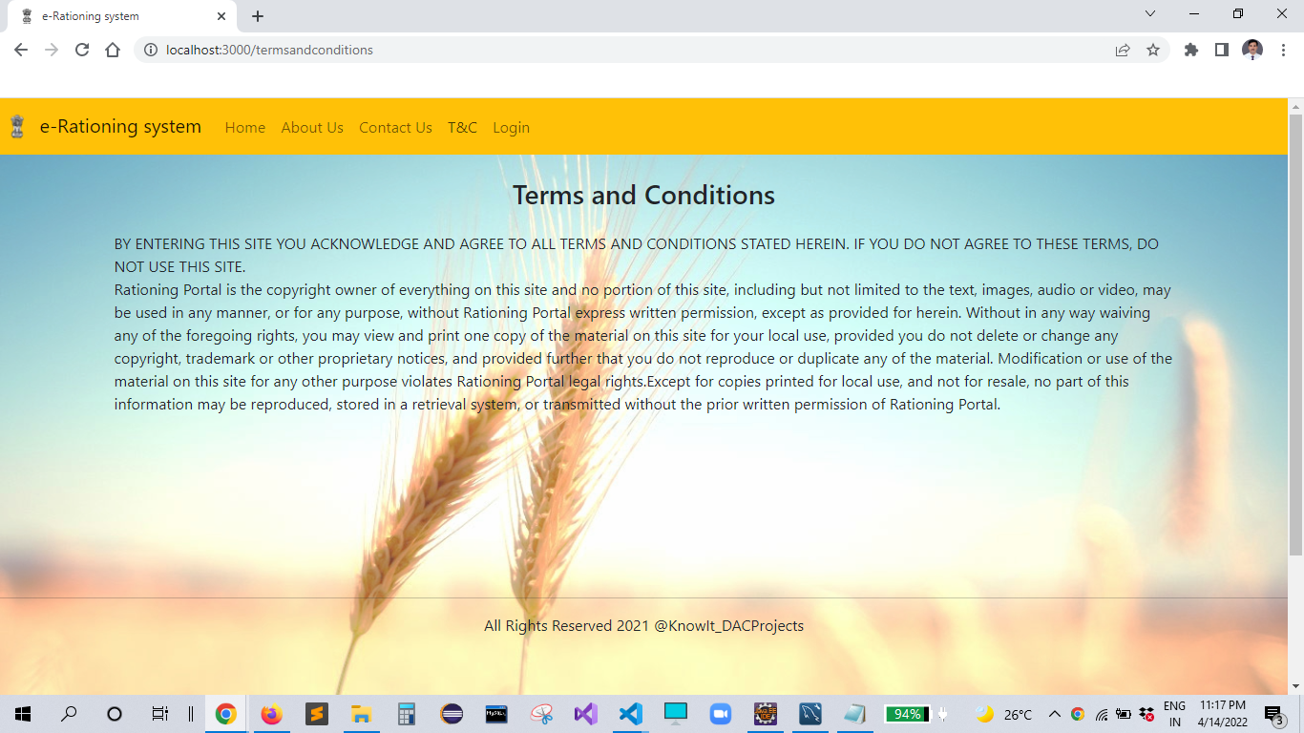

**8.5 Login Page**

Following snapshot shows the Login page for e-Rationing System

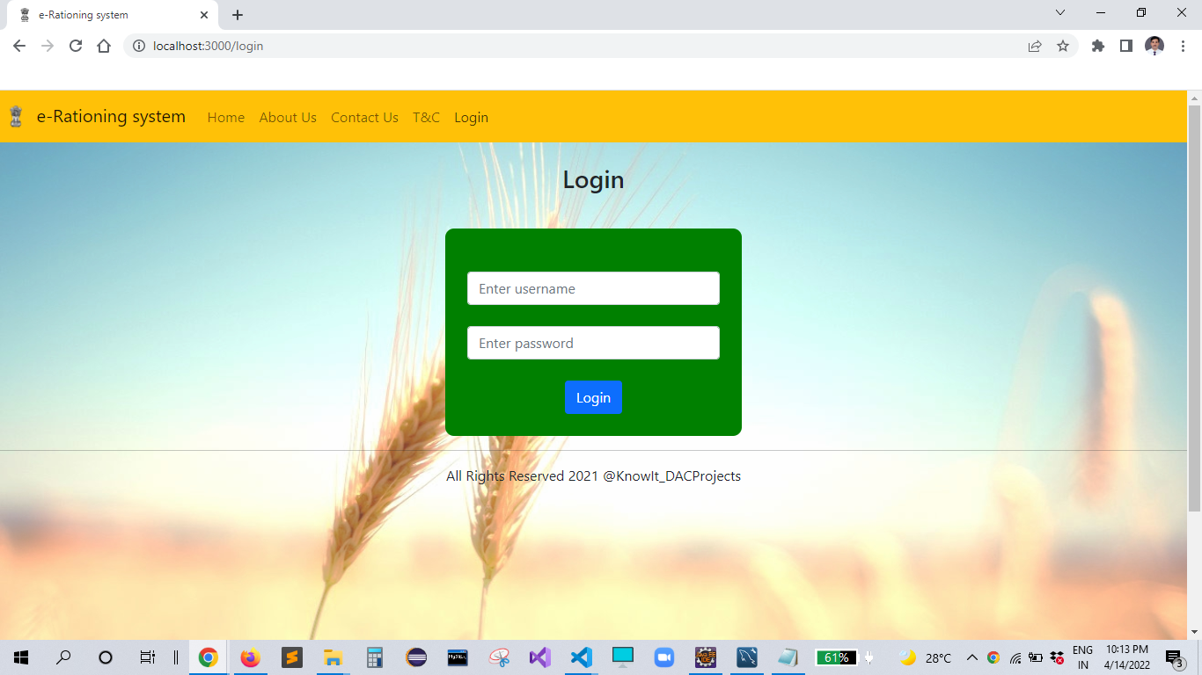

**8.5.1 Customer Page**

**Home page**

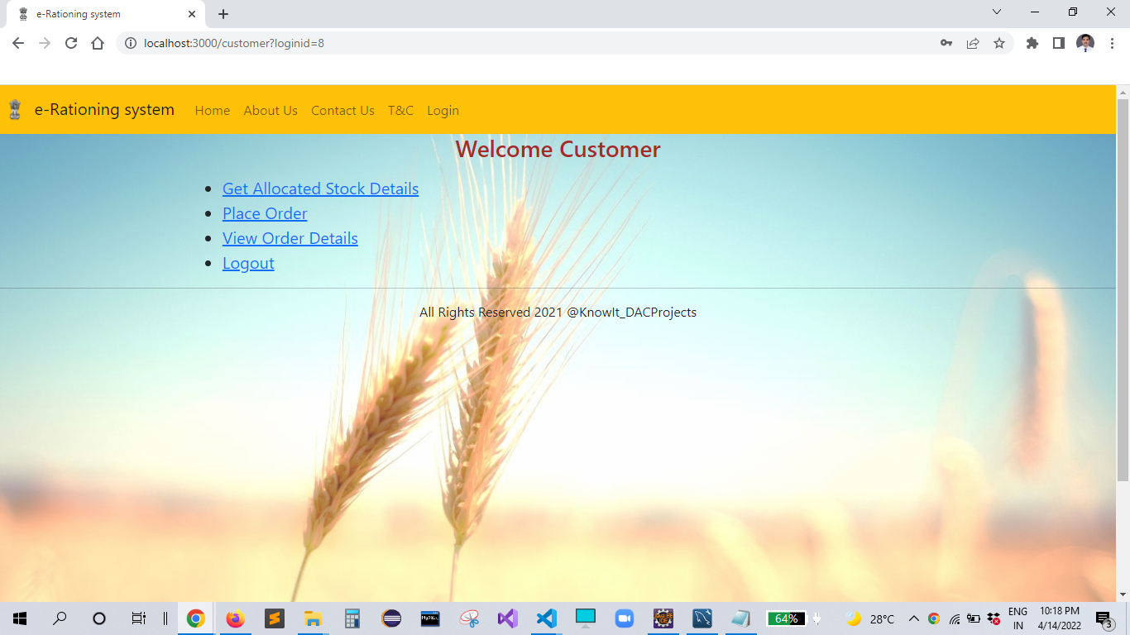

**Customer stock**

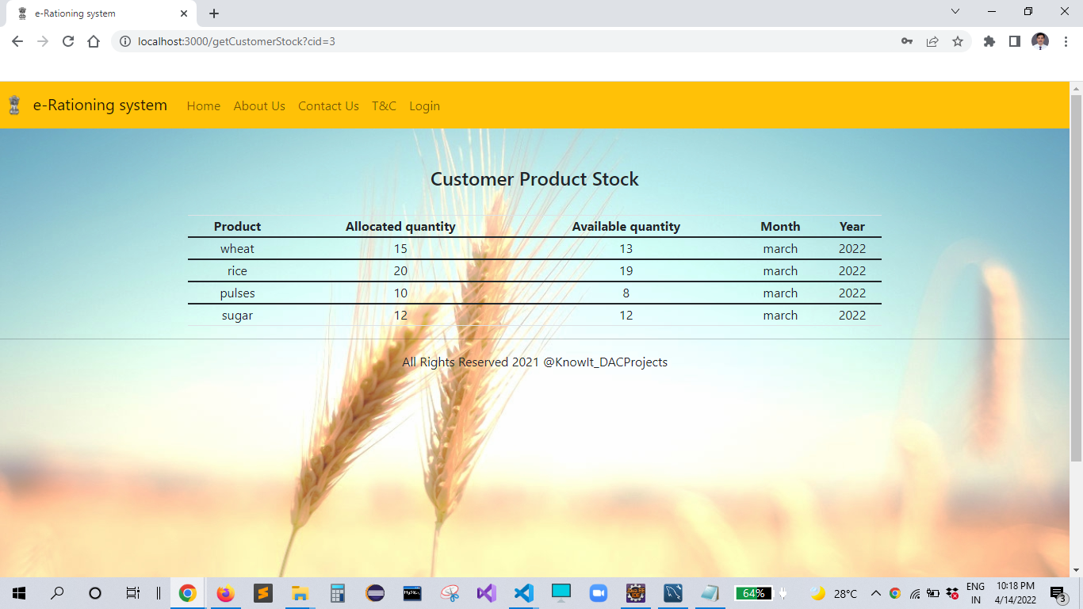

**Customer order**

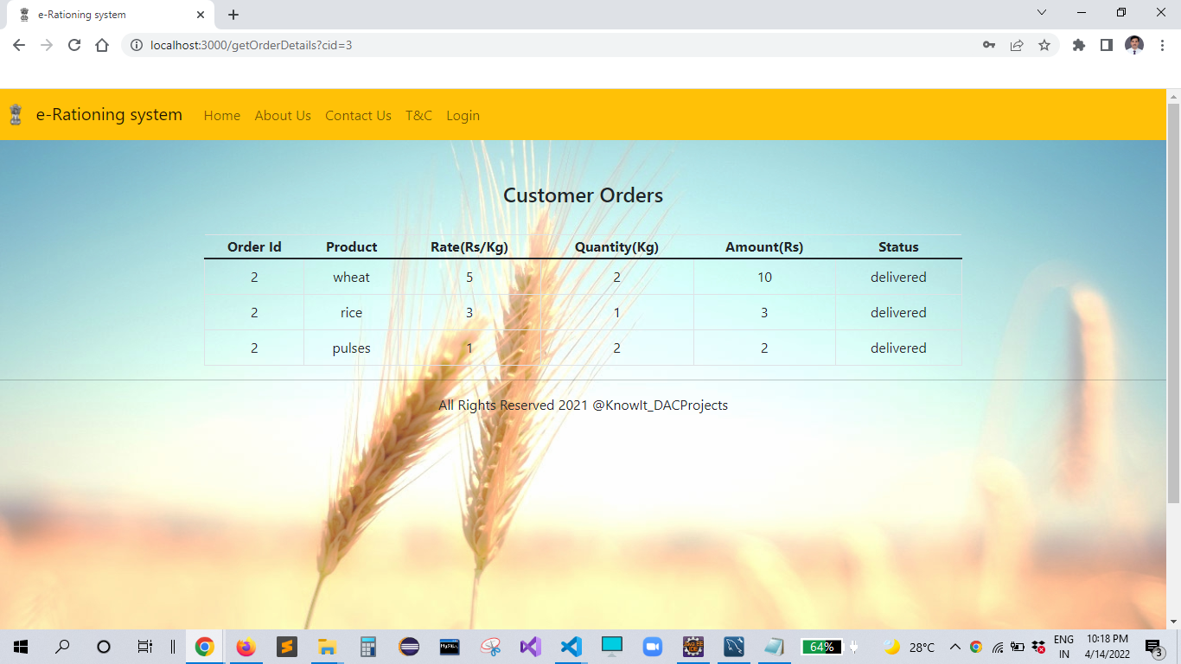

**8.5.2 Retailer Page**

**Home page**

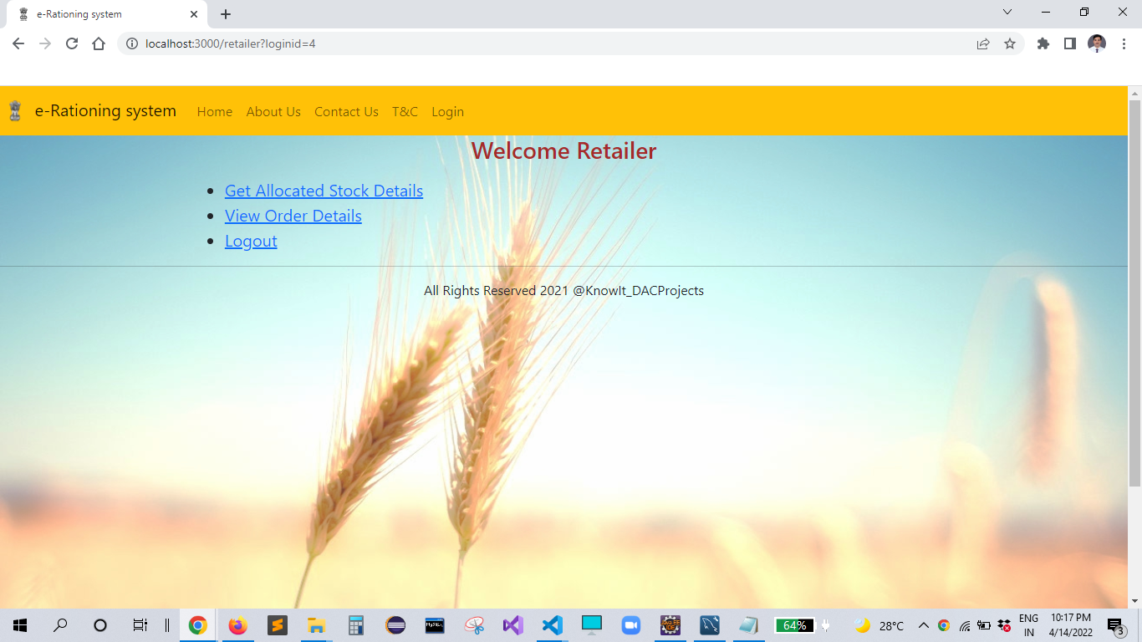

**Retailer stock**

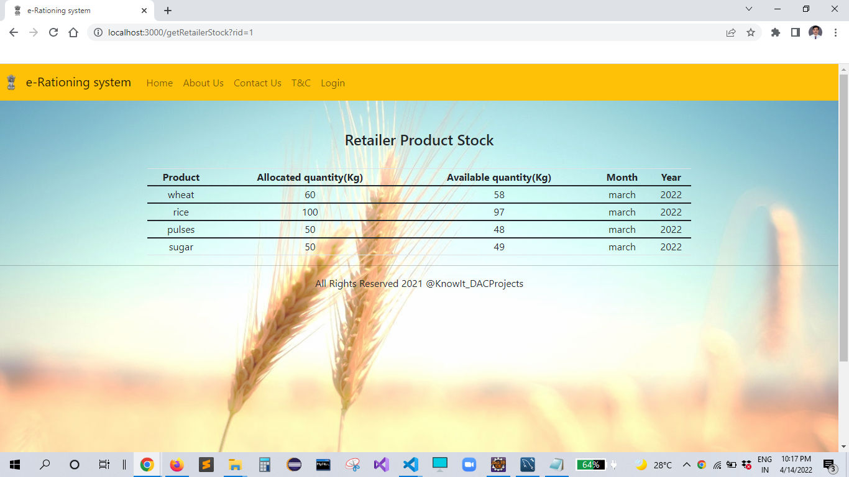

**Retailer order**

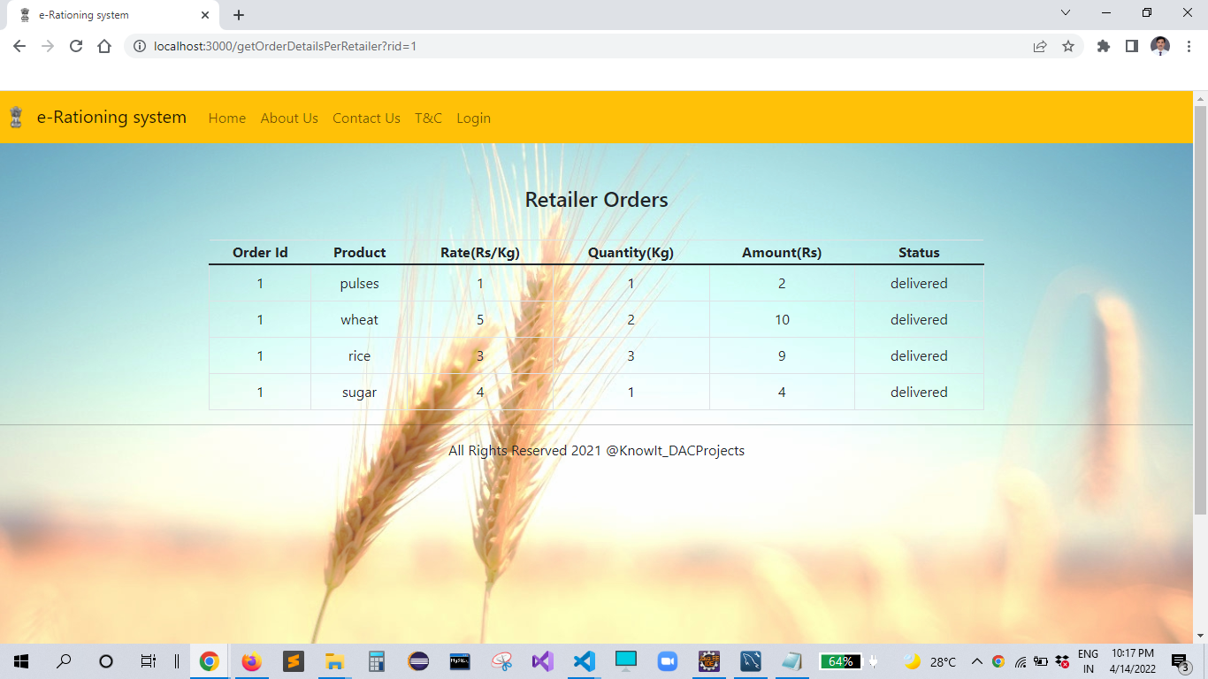

**8.5.3 Government Authority page**

**Home page**

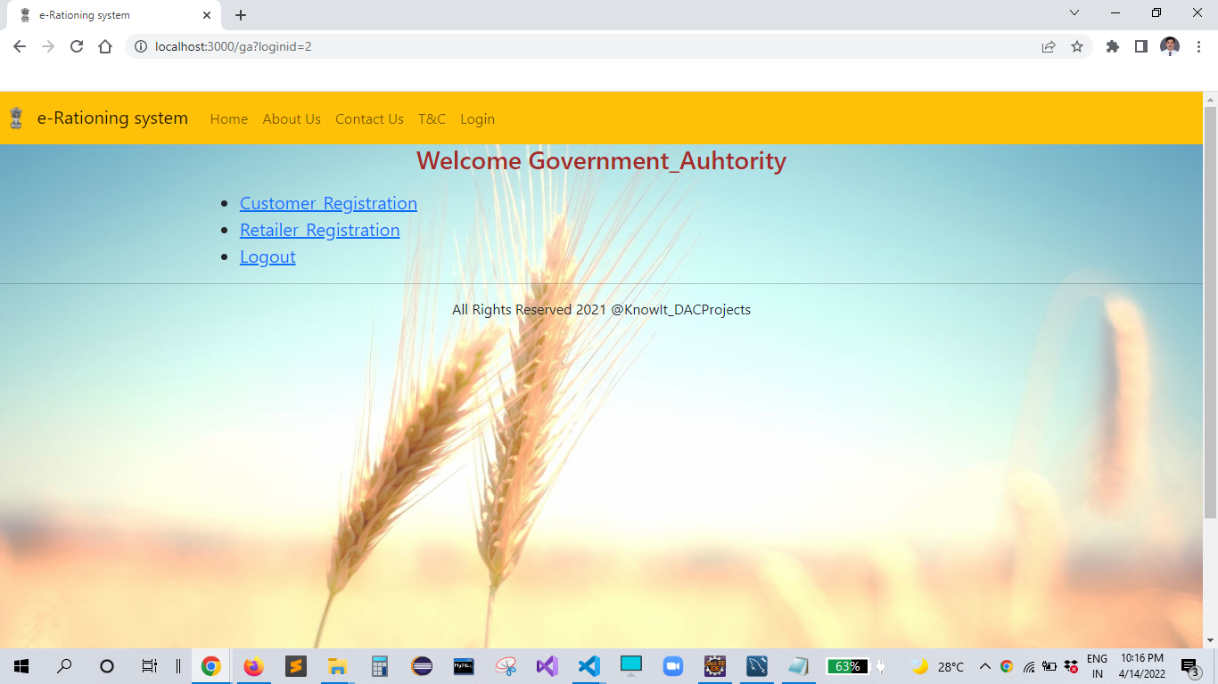

**Customer Registration Page**

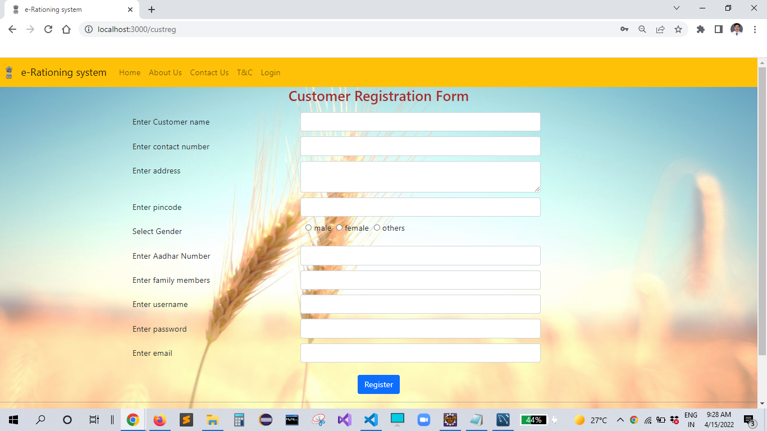

**Retailer Registration Page**

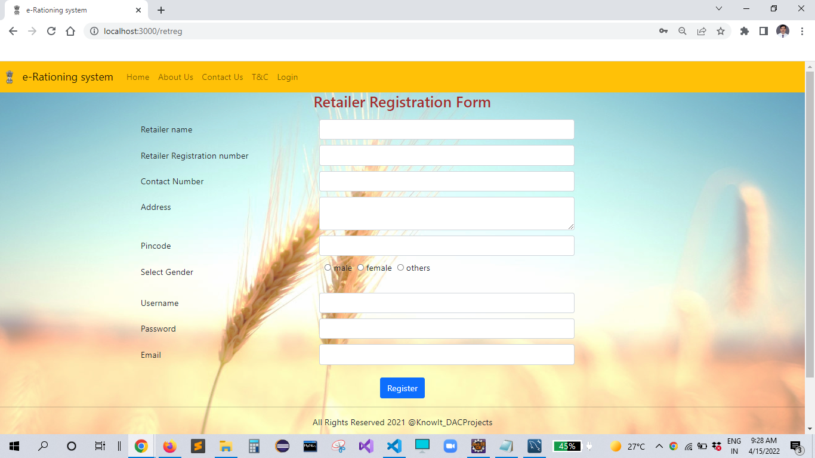

**8.5.4 Admin page**

**Home page**

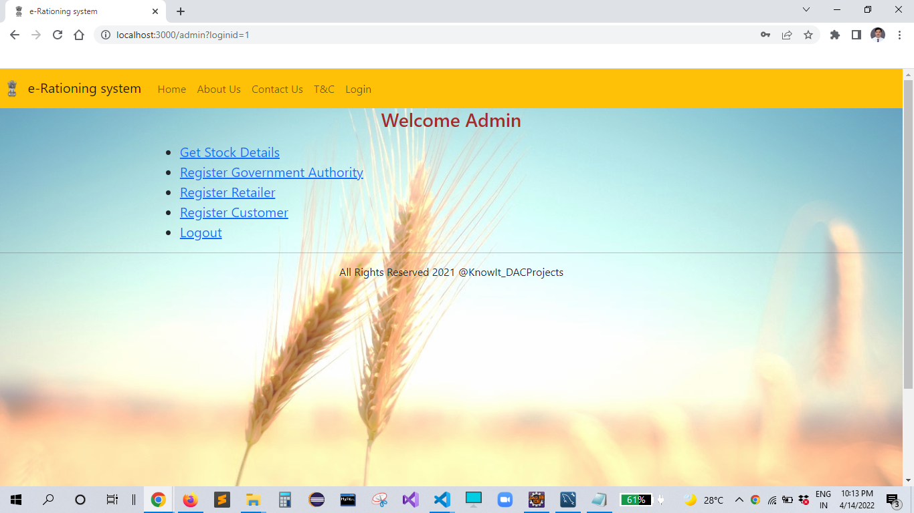

**Admin stock**

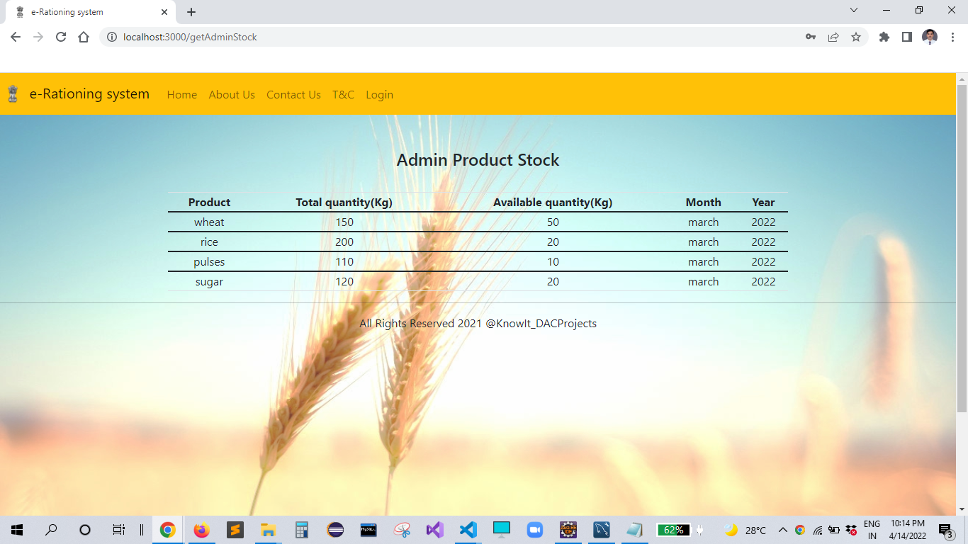

**Government Authority Registration Page**

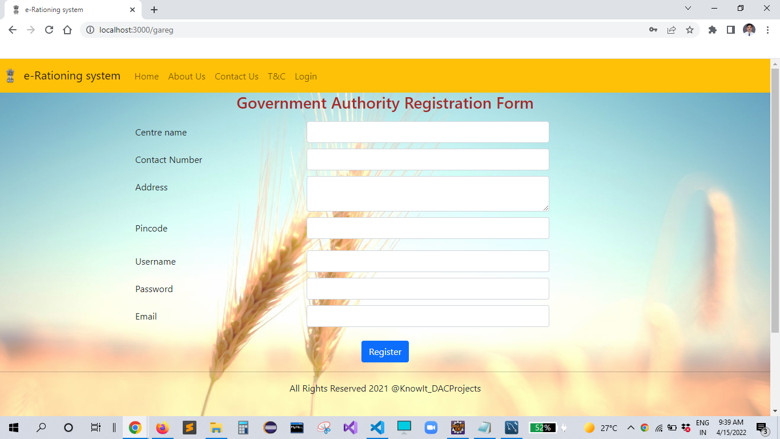

**Retailer Registration Page**



**Customer Registration Page**



**9. CONCLUSION AND FUTURE SCOPE**

E-Rationing system is developed to dispense the correct quantity of ration to the card holders depending on type the number of members in the family and maintain the details of transactions in database.

Also, this system will enable the government to keep track of the consumers and their transactions. E-Rationing system will reduce the security issues and malpractices present in the current PDS. This website will save a lot of time and avoid manual errors.

Our system is aiming to add extra feature in future where customer will be able to receive messages via SMS as well as he will be able to make payment through various digital platforms. we are also aiming to provide doorstep delivery.